**A**

#### PROJECT REPORT

*On*

**TRANSITIONS LENS STORE USING SCCOS**

*Submitted in partial fulfilment of the requirements for the degree of*

**BACHELOR OF TECHNOLOGY**



Session: - 2024

Under Guidance of

Mr. Aaditya Maheshwari Assistant Professor CSE

Dept. of CSE TINJRIT, Udaipur

Submitted by

Gaurav Jain (20ETCCS041) Archi Pamecha (20ETCCS009) Devesh Mali (20ETCCS030) Arnav Tyagi (20ETCCS011) Muskan Choudhary (20ETCCS076)

**DEPARTMENT OF COMPUTER SCIENCE AND ENGINEERING TECHNO INDIA NJR INSTITUTE OF TECHNOLOGY, UDAIPUR-313001**

**2024**

**A**

#### PROJECT REPORT

*On*

**Transitions Lens Store Using SCCOS**

*Submitted in partial fulfilment of the requirements for the degree of*

**BACHELOR OF TECHNOLOGY**



**Session: - 2024**

Under Guidance of

Mr. Aaditya Maheshwari Assistant Professor CSE Dept. of CSE TINJRIT, Udaipur

Submitted by

Gaurav Jain (20ETCCS041) Archi Pamecha (20ETCCS009) Arnav Tyagi (20ETCCS011) Devesh Mali (20ETCCS030) Muskan Choudhary (20ETCCS076)

8th Sem (CSE)

**DEPARTMENT OF COMPUTER SCIENCE AND ENGINEERING TECHNO INDIA NJR INSTITUTE OF TECHNOLOGY, UDAIPUR-313001**

**2024**



i

Department of Computer Science and Engineering Techno India NJR Institute of Technology, Udaipur-313001

## Certificate

This is to certify that project work titled **Transitions Lens Store Using SCCOS** by **Gaurav Jain** was successfully carried out in the Department of Computer Science and Engineering, TINJRIT and the report is approved for submission in the partial fulfillment of the requirements for award of degree of Bachelor of Technology in Computer Science and Engineering.

Mr. Aaditya Maheshwari Dr. Rimpy Bishnoi

Assistant Professor CSE Professor and HoD

Dept. of CSE TINJRIT, Udaipur Dept. of CSE TINJRIT, Udaipur

Date Date



ii

Department of Computer Science and Engineering Techno India NJR Institute of Technology, Udaipur-313001

## Certificate

This is to certify that project work titled **Transitions Lens Store Using SCCOS** by **Archi Pamecha** was successfully carried out in the Department of Computer Science and Engineering, TINJRIT and the report is approved for submission in the partial fulfillment of the requirements for award of degree of Bachelor of Technology in Computer Science and Engineering.

Mr. Aaditya Maheshwari Dr. Rimpy Bishnoi

Assistant Professor CSE Professor and HoD

Dept. of CSE TINJRIT, Udaipur Dept. of CSE TINJRIT, Udaipur

Date Date



iii

Department of Computer Science and Engineering Techno India NJR Institute of Technology, Udaipur-313001

## Certificate

This is to certify that project work titled **Transitions Lens Store Using SCCOS** by **Arnav Tyagi** was successfully carried out in the Department of Computer Science and Engineering, TINJRIT and the report is approved for submission in the partial fulfillment of the requirements for award of degree of Bachelor of Technology in Computer Science and Engineering.

Mr. Aaditya Maheshwari Dr. Rimpy Bishnoi

Assistant Professor CSE Professor and HoD

Dept. of CSE TINJRIT, Udaipur Dept. of CSE TINJRIT, Udaipur

Date Date



iv

Department of Computer Science and Engineering Techno India NJR Institute of Technology, Udaipur-313001

## Certificate

This is to certify that project work titled **Transitions Lens Store Using SCCOS** by **Devesh Mali** was successfully carried out in the Department of Computer Science and Engineering, TINJRIT and the report is approved for submission in the partial fulfillment of the requirements for award of degree of Bachelor of Technology in Computer Science and Engineering.

Mr. Aaditya Maheshwari Dr. Rimpy Bishnoi

Assistant Professor CSE Professor and HoD

Dept. of CSE TINJRIT, Udaipur Dept. of CSE TINJRIT, Udaipur

Date Date



v

Department of Computer Science and Engineering

Techno India NJR Institute of Technology, Udaipur-313001

## Certificate

This is to certify that project work titled **Transitions Lens Store Using SCCOS** by **Muskan Choudhary** was successfully carried out in the Department of Computer Science and Engineering, TINJRIT and the report is approved for submission in the partial fulfillment of the requirements for award of degree of Bachelor of Technology in Computer Science and Engineering.

Mr. Aaditya Maheshwari Dr. Rimpy Bishnoi

Assistant Professor CSE Professor and HoD

Dept. of CSE TINJRIT, Udaipur Dept. of CSE TINJRIT, Udaipur

Date Date

## Examiner Certificate

vi

This is to certify that the following student

**Gaurav Jain, Archi Pamecha, Arnav Tyagi, Devesh Mali and Muskan Choudhary** of final year B.Tech. (Computer Science and Engineering), was examined for the project work titled

#### Transitions Lens Store Using SCCOS

during the academic year 2023 – 2024 at Techno India NJR Institute of Technology, Udaipur

**Remarks:**

**Date:**

Signature Signature

(**Internal Examiner**) (**External Examiner**)

Name :- Name :-

Designation:- Designation:-

Department: - Department: -

Organization:- Organization:-

# ACKNOWLEDGMENT

vii

We take this opportunity to record our sincere thanks to all who helped us to successfully complete this work. Firstly, We are grateful to our **supervisor Mr. Aaditya Maheshwari** for his invaluable guidance and constant encouragement, support and most importantly for giving us the opportunity to carry out this work.

We would like to express our deepest sense of gratitude and humble regards to our **Head of Department Dr. Rimpy Bishnoi** for giving invariable encouragement in our endeavors and providing necessary facility for the same. Also a sincere thanks to all faculty members of CSE, TINJRIT for their help in the project directly or indirectly.

Finally, We would like to thank my friends for their support and discussions that have proved very valuable for us. We are indebted to our parents for providing constant support, love and encouragement. We thank them for the sacrifices they made so that we could grow up in a learning environment. They have always stood by us in everything we have done, providing constant support, encouragement and love

**Gaurav Jain (20ETCSS041) Archi Pamecha (20ETCCS009) Arnav Tyagi (20ETCCS011) Devesh Mali (20ETCCS030)**

**Muskan Choudhary (20ETCCS076)**

DEPARTMENT OF COMPUTER SCIENCE AND ENGINEERING TECHNO INDIA NJR INSTITUTE OF TECHNOLOGY, UDAIPUR-313001

**CONTENTS**

viii

|  |  |
| --- | --- |
| **Name of Contents** | **Page No.** |
| Certificate 1 | i-v |
| Certificate 2 | vi |
| Acknowledgements | vii |
| List of Tables | viii |
| List of Figures | ix-x |
| Chapter 1: Introduction   * 1. Title of Project   2. Introduction   3. Objective of the Project   4. Scope of the Project   5. Methodology | 1-2 |
| Chapter 2:Setup and Installation   * 1. Software Technology Used   2. Glue API   3. Server Requirements for PCs | 3-5 |
| Chapter 3: Spryker Cloud Commerce Operating System   * 1. Modular Architecture   2. Layered Architecture | 6-8 |
| Chapter 4:B2B Marketplace   * 1. Storefront   2. Backoffice | 9 |
| Chapter 5: Packaged Business Capabilities (PBCs) | 10-22 |
| Chapter 6: Transitions Lens Store | 23-27 |
| Bibliography | 28 |

**LIST OF FIGURES**

ix

|  |  |
| --- | --- |
| FIG.1 TECHNOLOGY STACK IN SPRYKER COMMERCE OS | 4 |
| FIG.2 GLUE API IN SPRYKER COMMERCE OS | 5 |
| FIG.3 SPRYKER COMMERCE OS | 6 |
| FIG.4 MODULAR ARCHITECTURE OF SPRYKER COMMERCE OS | 7 |
| FIG.5 LAYERED ARCHITECTURE OF SPRYKER COMMERCE OS | 8 |
| FIG.6 A) BACK-OFFICE B) STOREFRONT IN B2B MARKETPLACE | 9 |
| FIG.7 USER MANAGEMENT PBC (USER AUTHENTICATION) | 11 |
| FIG.8 PRODUCT MANAGEMENT USING CATEGORIES IN PBC | 12 |
| FIG.9 WISHLIST MANAGEMENT | 13 |
| FIG.10 PRICE MANAGING IN PRICE MANAGEMENT PBC | 14 |
| FIG.11 TAX MANAGEMENT IN B2B | 15 |
| FIG.12 DISCOUNT MANAGING | 16 |
| FIG.13 CONTENT ITEMS IN B2B MARKETPLACE | 17 |
| FIG.14 APPLYING FILTERS BY USING FILTER MANAGEMENT  PBC IN B2B MARKETPLACE | 18 |
| FIG.15 MANAGING ORDERS IN B2B MARKETPLACES | 19 |
| FIG.16 WAREHOUSE MANAGEMENT | 20 |
| FIG.17 CART MANAGEMENT IN B2B | 21 |
| FIG.18 RATINGS AND REVIEWS IN B2B MARKETPLACE | 22 |
| FIG.19 BACKOFFICE HISTORY | 23 |
| FIG. 20 APPLYING BRAND FILTER FOR A SPECIFIC BRAND “  EYEBUYDIRECT” | 24 |
| FIG.21 ITEMS SHOW IN THE CART MADE BY CUSTOMER | 24 |
| FIG.22 PAGE SHOWING THE FEATURED PRODUCTS ON THE  WEBSITE | 25 |
| FIG.23 FRONTPAGE OF THE ECOMMERCE WEBSITE | 25 |
| FIG.24 SHOWING THE CONFIRMED ORDER | 26 |

x

|  |  |
| --- | --- |
| FIG.25 SHOWING THE CONFIRMED ORDER FOR THE  AUTHENTICATED CUSTOMER | 26 |
| FIG.26 PRODUCT CATALOG | 27 |
| FIG.27 TOP CATEGORIES OF TRANSITIONS LENS STORE | 27 |

**CHAPTER 1: INTRODUCTION**

**Name of the project:**

TRANSITIONS LENS STORE USING SCCOS

**Problem Statement:**

In this project we will develop a robust e-commerce platform utilizing the latest tool, Spryker Commerce, to efficiently handle and manage product information and conduct seamless e-commerce activities. The platform will serve as a comprehensive solution to facilitate online retail operations, providing a user-friendly interface for both customers and administrators.

**Objective of the project:**

Trade shift covers over 160+ countries, giving us the largest global reach of any online B2B platform. Giving you access to collaborative tools, expanded connections, and insightful analytics, our network is the one solution you need to connect with hundreds of buyers and sellers. Not only do suppliers gain instant access to potential new buyers on our platform, but our seamless, digital interactions showcase clear value for both parties. To demonstrate the B2B features in a live implementation, we use a B2B marketplace. The B2B marketplace is a showcase that is preloaded with a combination of modules and functionalities best suited for B2B commerce. This Demo Shop is our recommended starting point for all standard B2B commerce projects. New features for the B2B marketplace are released every several months.

**Scope of the project:**

The scope of the project is to display products in the catalogue, customers can select a variety of products and manage the quantity of the product. Selected items will be collected in a cart. At checkout, the item in the cart will be presented as an order, customer can apply various discount coupons on it, also customer will get options to pay for that order via Card, UPI, Net banking or Cash on delivery. Further systems will generate an invoice for the order. For security of the user, users have to login through login ID and password, so that no unauthorised user can access your account.

1

**Methodology:**

2

1. Functionalities to browse through product catalogue.
2. Product order module.
3. Administrator of the Application having access to all modules.
4. Different facilities and authorisation to different users like customers, admin, Inventory manager, support team, Seller.
5. Integration with Payment Gateway
6. Customer Review and feedback system
7. Tracking the Logistics

# CHAPTER 2: SETUP AND INSTALLATION

3

**Software/ Technology used:**

* + Docker
  + Ubuntu
  + PHP
  + Spryker commerce cloud OS: Spryker uses a set of well-known tools:
    - Redis. Redis is the most popular key-value database; the name is an abbreviation for Remote Dictionary Server. In Spryker it’s used as a client- side data source for localized content.
    - Elasticsearch. Elasticsearch is a distributed search engine that offers an easy-to-configure and easy-to-integrate solution for making searches fast. The relevant search data is stored in dedicated storage, so is similar to using Redis storage; it avoids making a costly query to the SQL database. The data stored in Elasticsearch is updated through cronjobs.
    - Twig. It is a fast and modern PHP templating engine.
    - Propel. It is an ORM library for PHP, offering an object-relational mapping toolkit. It’s part of the Symfony framework.
    - Database: MySQL, MariaDB, or PostgreSQL. Spryker supports MySQL, MariaDB, or PostgreSQL. You can configure it in the main configuration file.

4

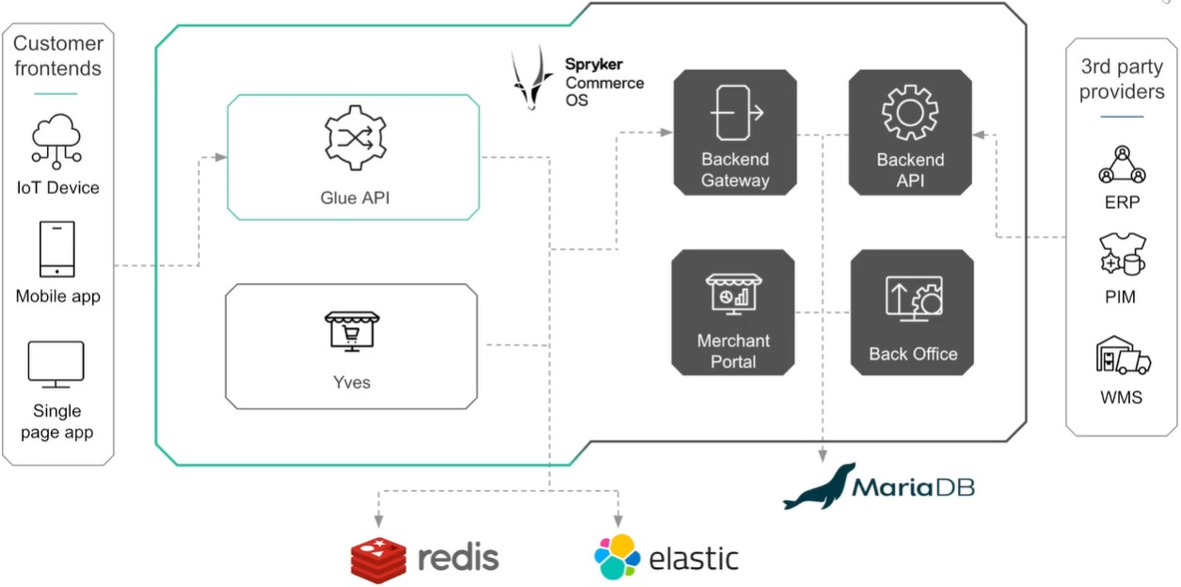

**Fig.1 Technology Stack in Spryker Commerce OS**

**Glue API:**

5

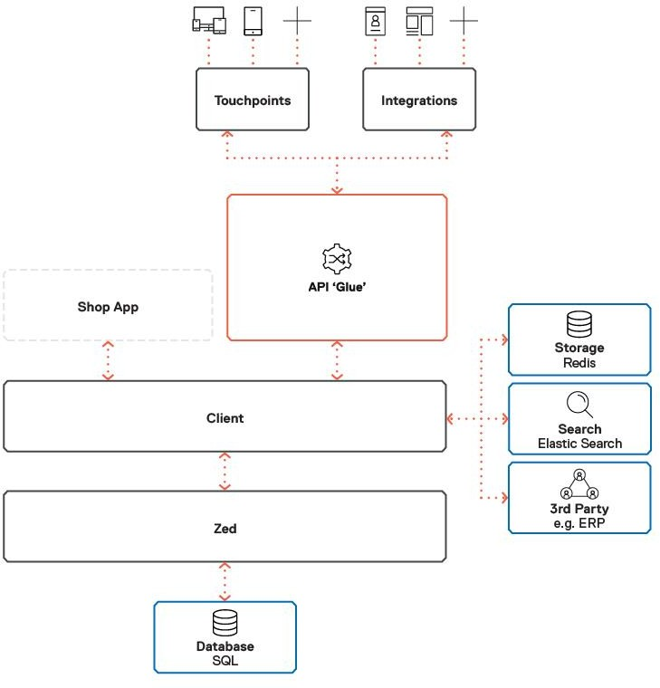

**Fig.2 Glue API in Spryker Commerce OS**

* + GitHub
  + Visual Studio Code

**Server requirements for the PCs**

* + Spryker Local Host Server

# CHAPTER 5: SPRYKER CLOUD COMMERCE OPERATING SYSTEM

### Spryker Commerce OS:

The Spryker Commerce OS (SCOS) is a completely modular B2B and B2B e- commerce technology. With the modular application and API- based integration with all possible customer touchpoints (front-ends), SCOS provides significantly shorter time-to-market and reduced total cost of ownership, while increasing your ROI due to the digital best practices.

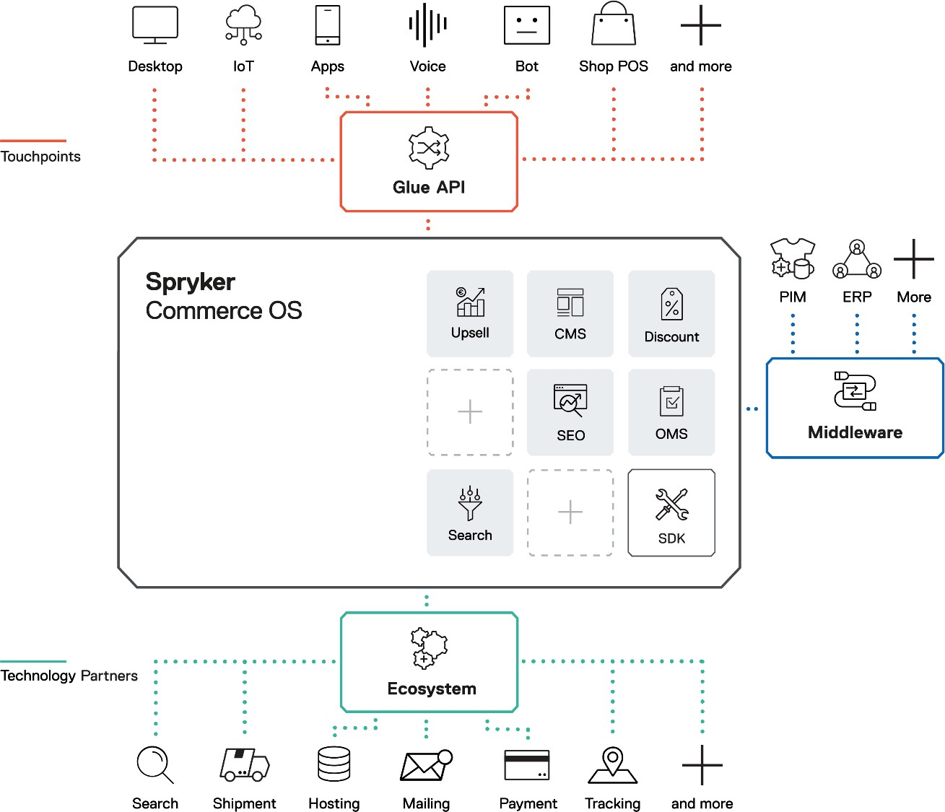

**Fig.3 Spryker Commerce OS**

6

We establish a unique advantage for our customers by creating a commerce operating system that revolves around two cornerstones for success: modular and layered architectures.

### Modular Architecture:

Modular architecture, or modularity of the Spryker Commerce OS, means that the system is composed of small parts called modules. The Spryker Commerce OS consists of over 750 modules. Some of them are mandatory and required by the OS to run, but many are optional and designed to provide certain functionality or connectivity to either internal or external systems. The modules combine to create features and have limited dependencies. The limited dependencies imply less development effort, increasing your return on investment and lowering the total cost of ownership.

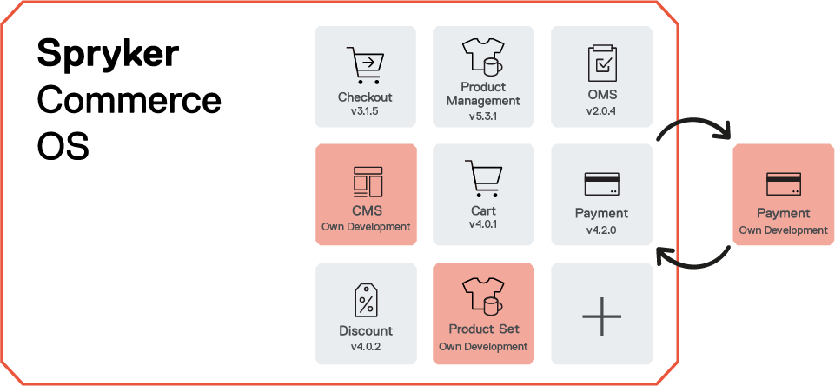

**Fig.4 Modular Architecture of Spryker Commerce OS**

### Layered architecture:

Layered Architecture is used to separate your commercial offering and sales channels. When your commercial offering is hooked directly to an online web store, expanding to different channels and methods of selling poses a huge challenge in most cases.

7

8

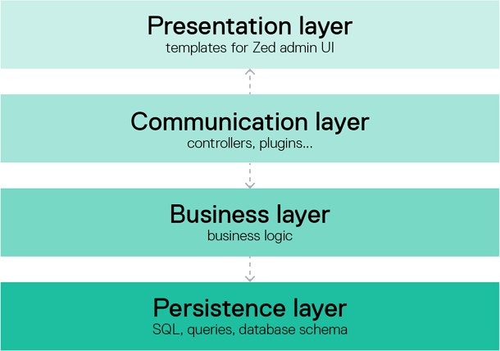

**Fig.5 Layered Architecture of Spryker Commerce OS**

# CHAPTER 4: B2B MARKETPLACE

9

### B2B marketplace:

To demonstrate the B2B features in a live implementation, we use a B2B marketplace. The B2B marketplace is a showcase that is preloaded with a combination of modules and functionalities best suited for B2B commerce. This Demo Shop is our recommended starting point for all standard B2B commerce projects. New features for the B2B marketplace are released every several months.

We are using a Spryker B2B marketplace that is **a live representation of all the capabilities we have in the B2B Suite.**

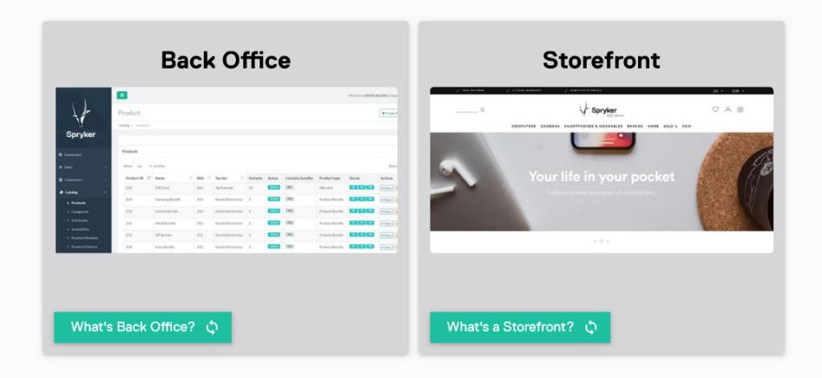

**Fig.6 a) Back Office b) Storefront in B2B marketplace**

**Back Office** is an administration interface that allows to manage customers and products, shop navigation and content, orders, and returns effectively.

**A storefront** is a web shop where customers can view a product catalog and place orders.

## CHAPTER 5: PACKAGED BUSINESS CAPABILITIES (PBCs)

**Packaged Business Capabilities (PBCs):**

Packaged Business Capabilities (PBCs) are capabilities that enclose a certain functionality with the Spryker system. PBCs provide a good foundation for decision makers throughout multiple business entities.

PBCs are used in B2B marketplaces in order to get the full understanding on how to operate a B2B shop and to find out how to:

* Manage users,
* Create products,
* Change prices,
* Apply discounts,
* Set up filters,
* Process orders
* and much more.

B2B shop includes the following below mentioned PBCs: -

* User Management PBC
* Product Information Management PBC
* Shopping List and Wishlist PBC
* Price Management PBC
* Tax Management PBC
* Discount Management PBC
* Content Management System PBC
* Search and Filters
* Order Management PBC
* Warehouse Management PBC
* Cart and Checkout PBC
* Ratings and Reviews PBC

10

**User Management PBC:**

##### DESCRIPTION: -

Lets the Back Office users manage user access, set rights, and onboard customers. BENEFITS: -

Ensures high security and compliance through managed user flows.

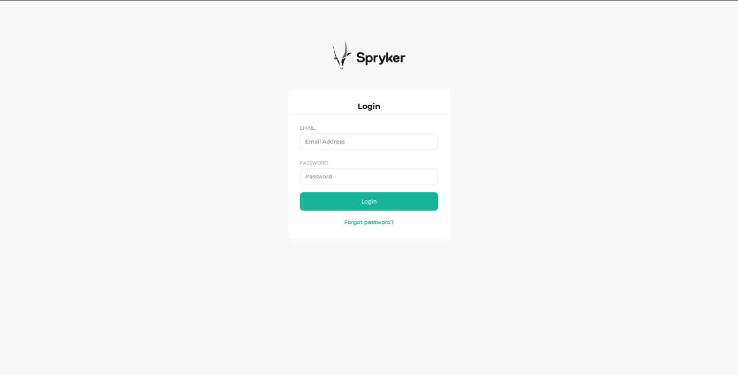

**Fig.7 User Management PBC (User Authentication) Product Information Management PBC:**

##### DESCRIPTION: -

Encompasses all functionality that is needed to set up your product catalog. With PIM, you can create and extend the product catalog to match your business needs.

##### BENEFITS: -

Helps you expand your business by organizing your products in a fast and efficient way.

11

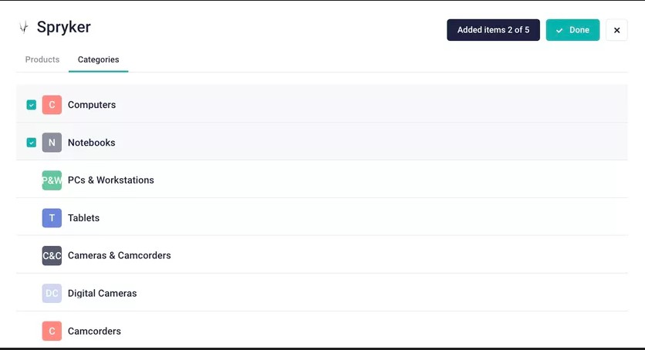

**Fig.8 Product Management using Categories in PBC**

**Shopping List and Wishlist PBC:**

##### DESCRIPTION: -

Your B2B customers can save the products they wish to purchase, in shopping lists. Different roles and permission systems ensure smooth sharing and contribution management amongst company users. This PBC encompasses additional features like printing, barcode generation, and direct-to-cart. Enabling your B2B customers to track and save the products they wish to purchase through a wish list function effectively reduces cart abandonment, boosts your sales, and allows you to keep track of which products are of interest to your customers.

##### BENEFITS: -

Lets you increase conversion rates and loyalty by offering rich Shopping and B2B Wish Lists.

12

13

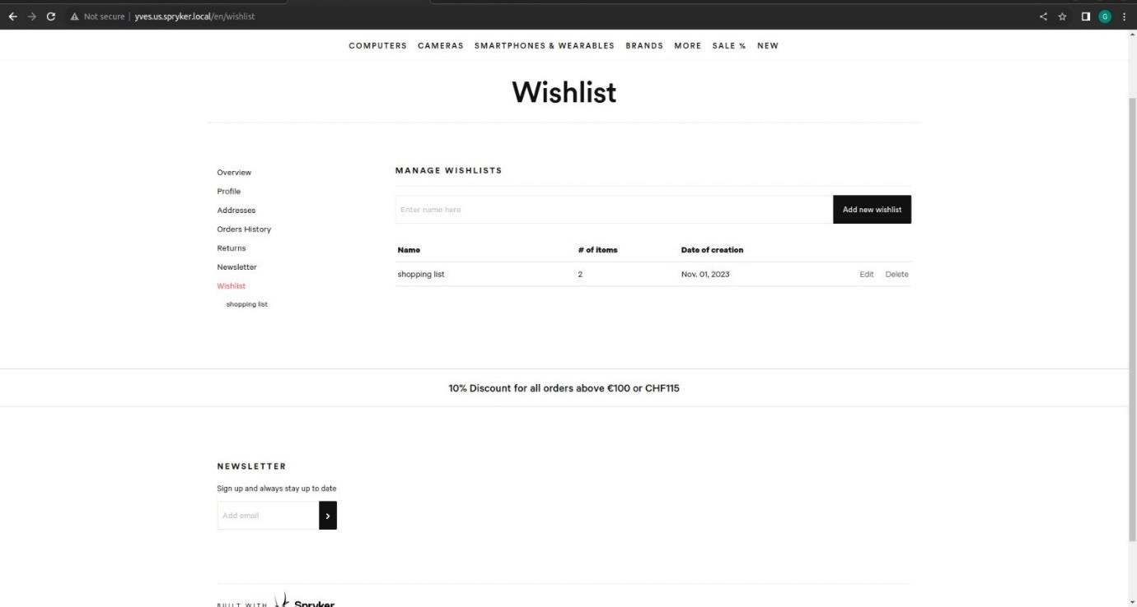

**Fig.9 Wishlist Management in B2B Marketplace**

**Price Management PBC:**

##### DESCRIPTION: -

The Spryker Cloud Commerce OS supports multiple currencies and automatically detects the payment currency based on a customer’s preference. You can manage gross and net prices per product and per country. You can also offer volume discounts to encourage customers to purchase products in larger quantities.

##### BENEFITS: -

Saves you time by letting you implement your pricing strategy in one place and catering it to your business needs.

14

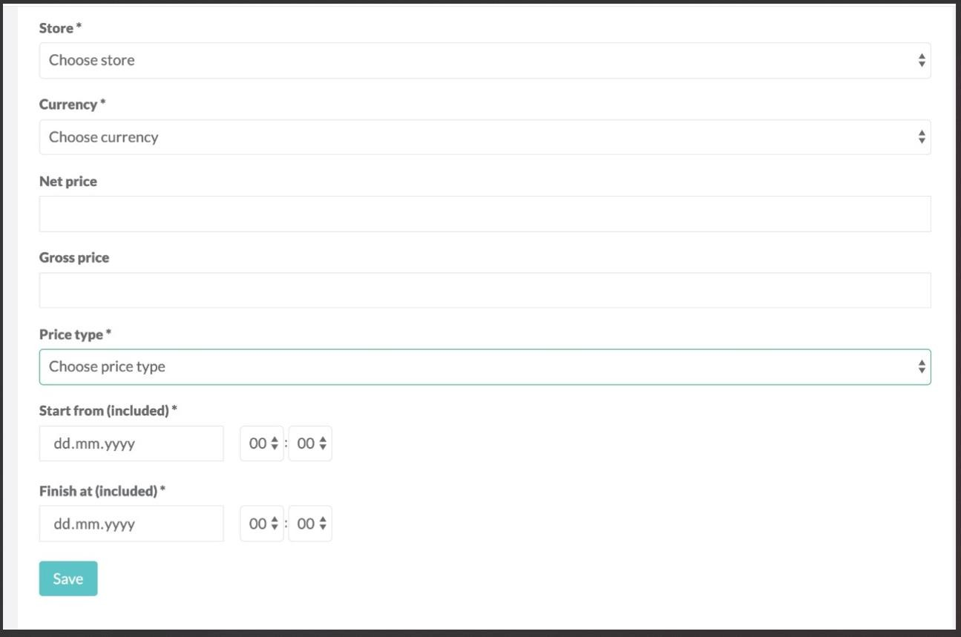

**Fig.10 Price Managing in Price Management PBC in B2B Marketplace**

**Tax Management PBC:**

##### DESCRIPTION: -

Lets you adhere to respective tax regulations in the countries you sell by configuring and managing tax rates for products, shipments, and additional services. You can define tax rates for different countries and apply integrations to manage US taxes.

##### BENEFITS: -

Lets you comply with fiscal regulations.

15

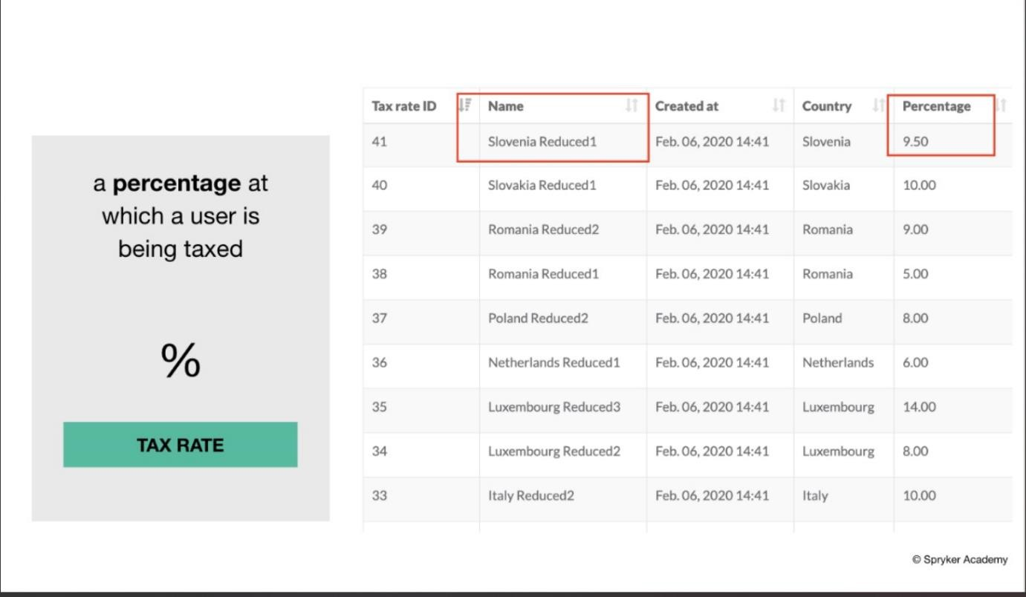

**Fig.11 Tax Management in B2B in B2B Marketplace**

**Discount Management PBC:**

##### DESCRIPTION: -

You can define several types of discounts based on a brand, the overall cart value, specific product ranges, or unique customer groups. You can also offer discount vouchers or incentivize certain products through coupon codes.

##### BENEFITS: -

Lets you run effective promotional campaigns to boost conversion rates.

16

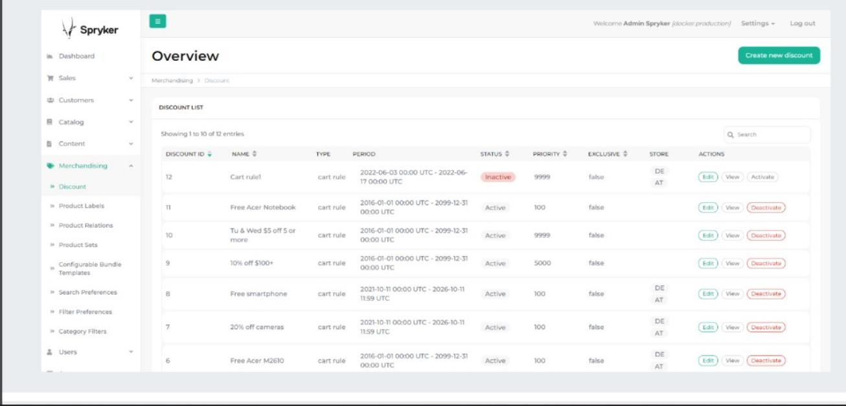

**Fig.12 Discount Managing in B2B Marketplace**

**Content Management System (CMS):**

##### DESCRIPTION: -

The CMS features let you customize your store, enrich it with information, stories, or other content, and make it easily findable in search engines. Several SEO features enable you to add customized meta information to all your content and create search engine-friendly URLs.

##### BENEFITS: -

Provides compelling content and stories where your customers need it.

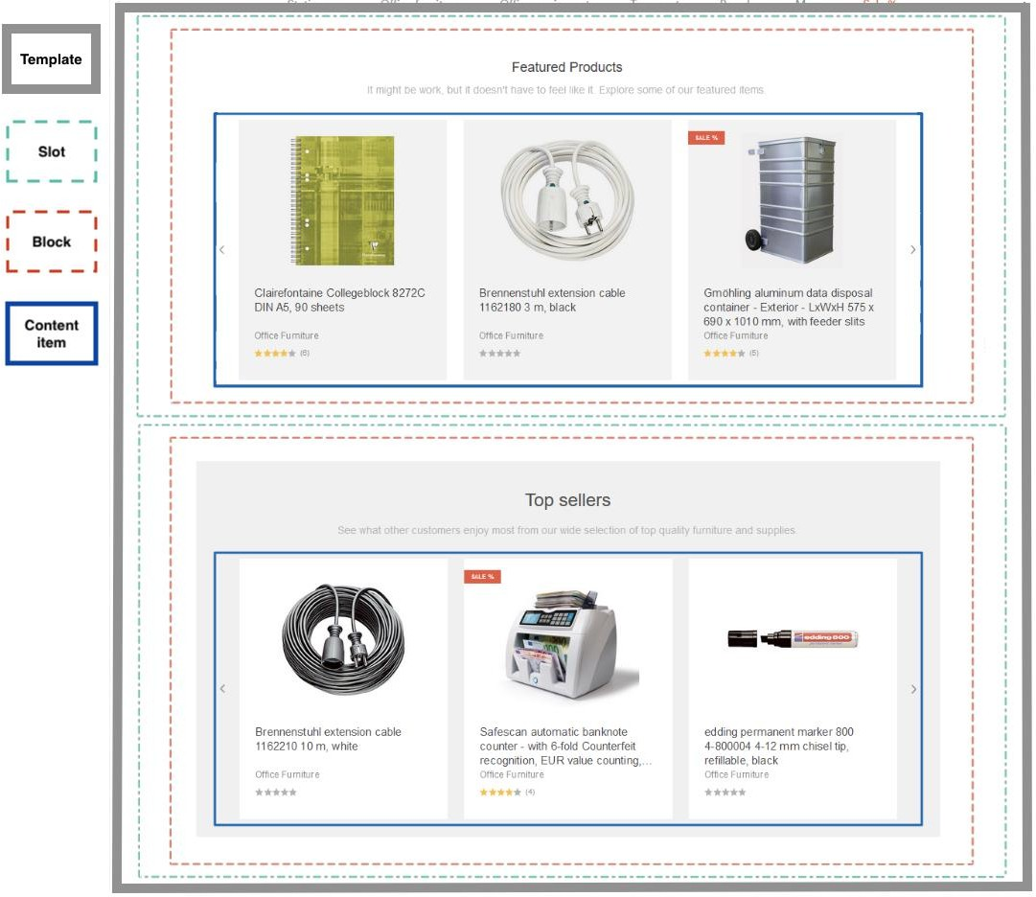

**Fig.13 Content Items in B2B Marketplace**

**Search and Filters PBC:**

##### DESCRIPTION: -

The out-of-the-box Elasticsearch technology lets you include full-text search, auto- suggestions, and auto-completion. You can set individual search preferences for multiple stores and categorize your products by adding dynamic filters and facets to help your customers further refine the search results. You can also add more advanced filters that use the product’s metadata or promote a brand’s top-sellers or highly rated products.

##### BENEFITS: -

17

Helps you increase conversion rates by providing an excellent Search and Filter experience.

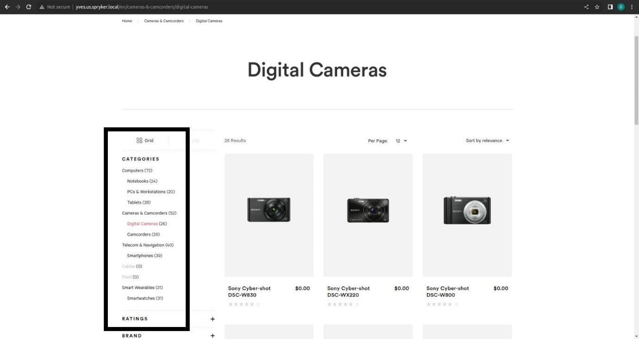

**Fig.14 Applying filters by using Filter Management PBC in B2B marketplace**

**Order Management PBC:**

##### DESCRIPTION: -

Helps you keep track of your order processing from your B2B, B2B, or Marketplace, and ensure quick fulfilment. You can manage incoming orders in the Back Office, view and edit orders, track their progress, or contact customers who make open orders directly. With the compact Order Management features, you can keep your order processing running smoothly.

##### BENEFITS: -

Lets you Process orders smoothly to fulfil them quickly.

18

19

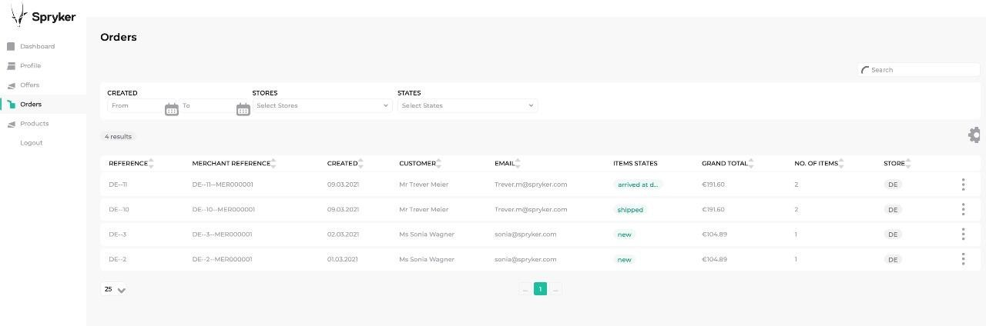

**Fig.15 Managing orders in B2B marketplace**

**Warehouse Management PBC:**

##### DESCRIPTION: -

Lets you keep an overview of your stock levels in the Back Office to determine accurate availabilities on your store’s website. Any open orders or reserved items are taken into consideration when stock availabilities are displayed.

##### BENEFITS: -

Helps you save your time by keeping an eye on your stock levels.

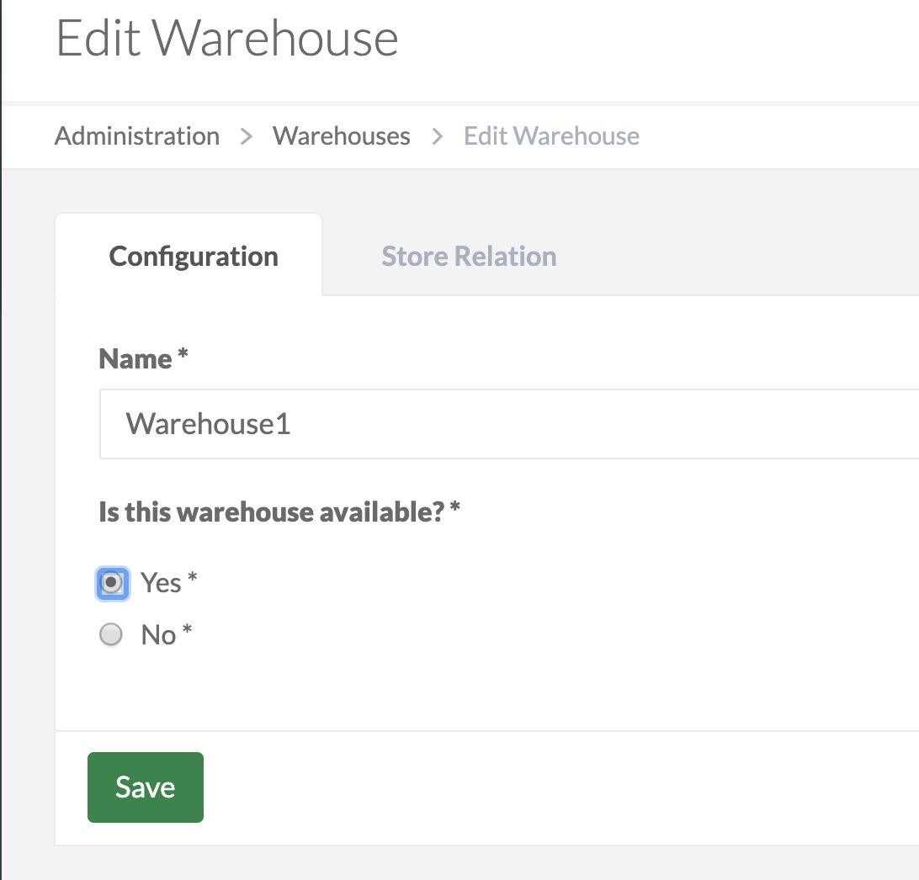

**Fig.16 Warehouse Management in B2B Marketplace**

**Cart and Checkouts PBC:**

##### DESCRIPTION: -

The online shopping cart and checkout process act as a gateway for customer and order management. It lets your customers organize and manage their purchases, apply vouchers and coupon codes. Based on their roles and permissions, your B2B customers can add or remove products, share the cart, and manage their purchases.

20

##### BENEFITS: -

Increases conversion rates and reduces drop-off rates. Offers additional B2B specific, permission-related functionalities.

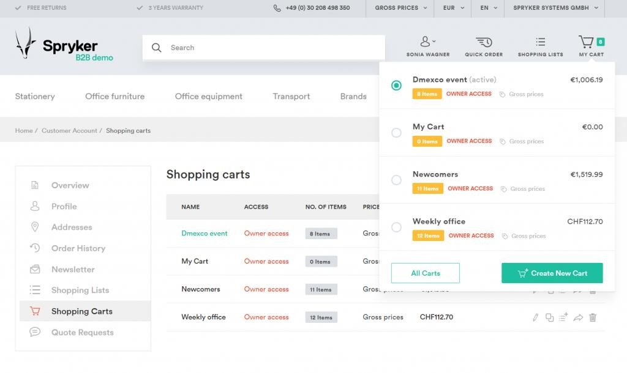

**Fig.17 Cart management in B2B Marketplace**

**Ratings and Review PBC:**

##### DESCRIPTION: -

Lets you incorporate user reviews and ratings. You can receive and moderate feedback in the Back Office. The Ratings and Reviews feature also comes with the functionality to add text-free reviews and star ratings.

##### BENEFITS: -

Inspires trust among customers with ratings and reviews.

21

22

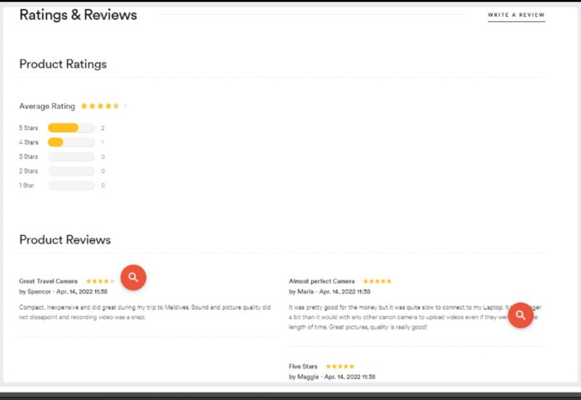

**Fig.18 Ratings and Reviews in B2B Marketplace**

# CHAPTER 6: TRANSITIONS LENS STORE

## Description:

Our major project focuses on a B2B ecommerce website catering to eyewear and eye lens products. Our platform efficiently manages product information and facilitates seamless e-commerce activities. Users can browse through various brands' products, add items to their cart, and adjust quantities as needed. During checkout, customers can apply discount coupons and choose from multiple payment options including Card, UPI, Net banking, or Cash on delivery. The system generates invoices for orders for transparency and record-keeping. To ensure user security, login credentials are required, preventing unauthorized access. Our goal is to provide a user-friendly and secure platform for businesses to conduct eyewear transactions smoothly.

Below mentioned are the screenshots of our website for different operations done:

These captures shows the backoffice , Cart and Checkout , Review and Ratings , Product Catalog ,Featured Products etc.

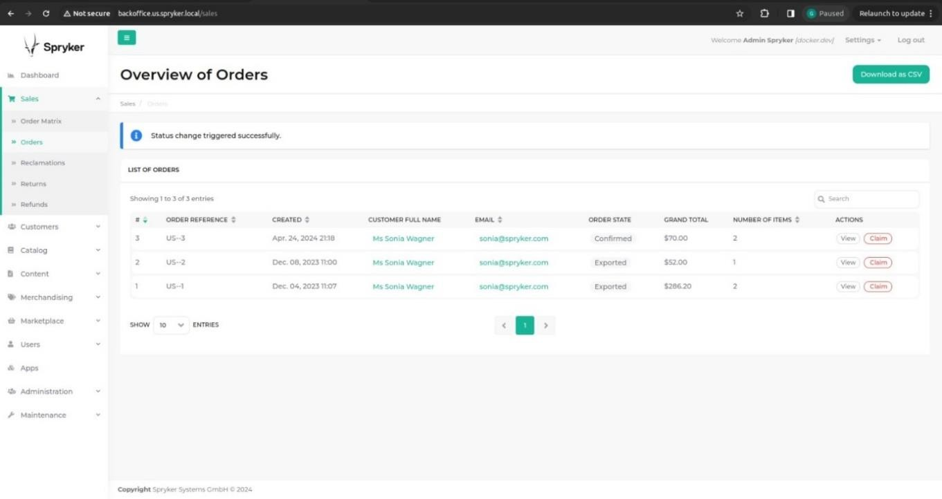

**Fig.19 Backoffice History**

23

24

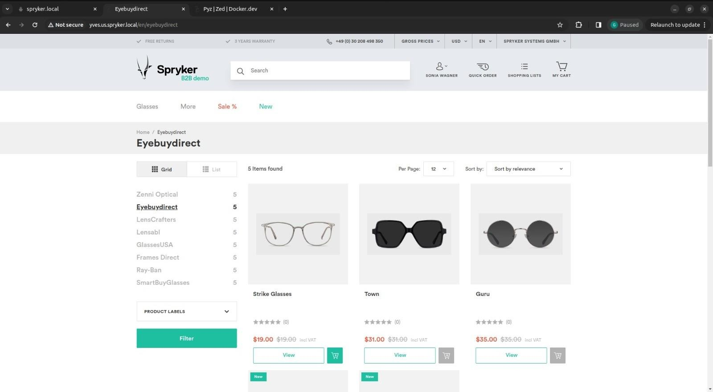

**Fig. 20 Applying Brand Filter for a specific brand “ Eyebuydirect”**

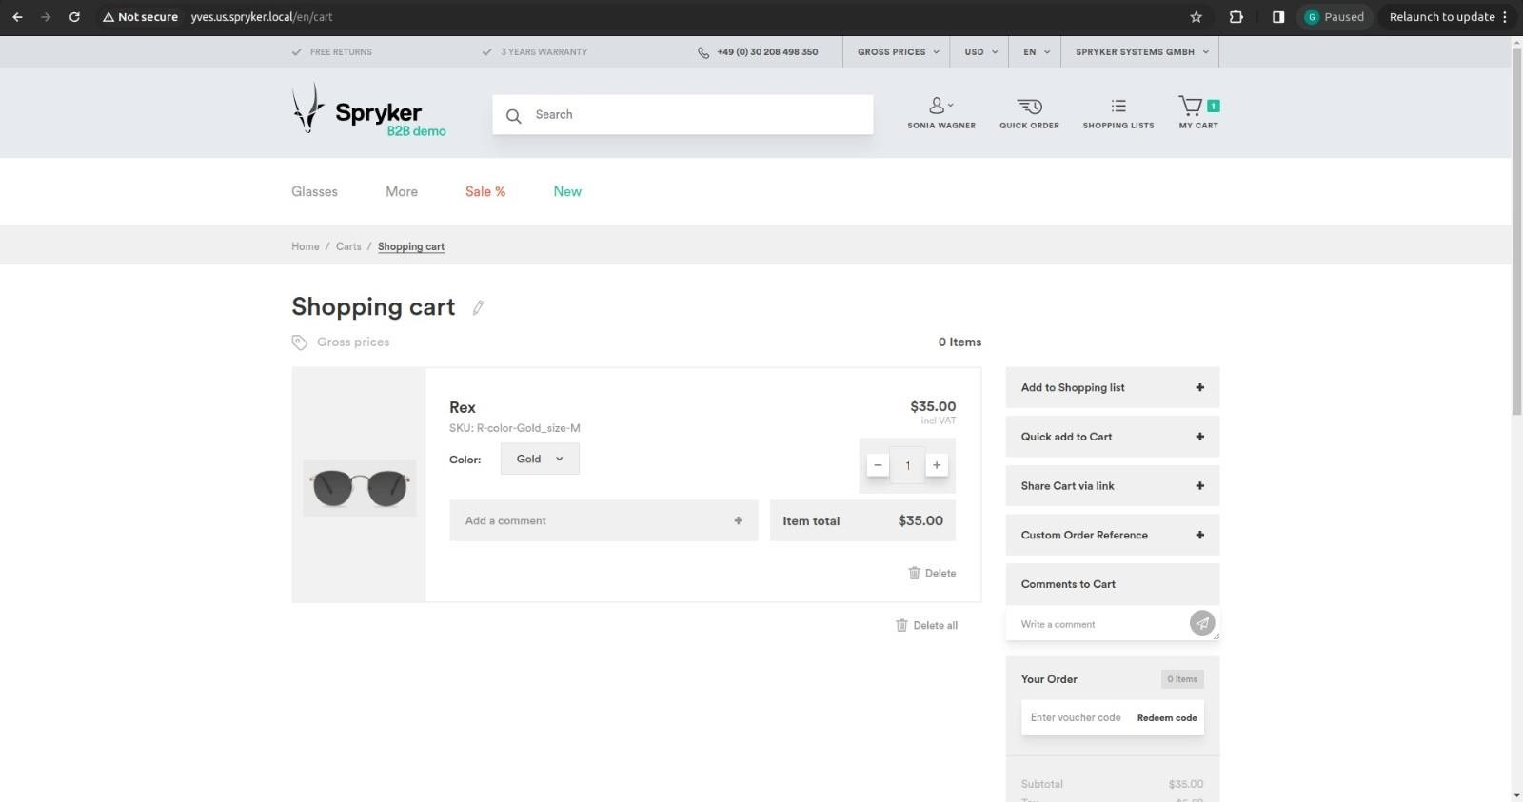

**Fig.21 Items show in the cart made by customer**

25

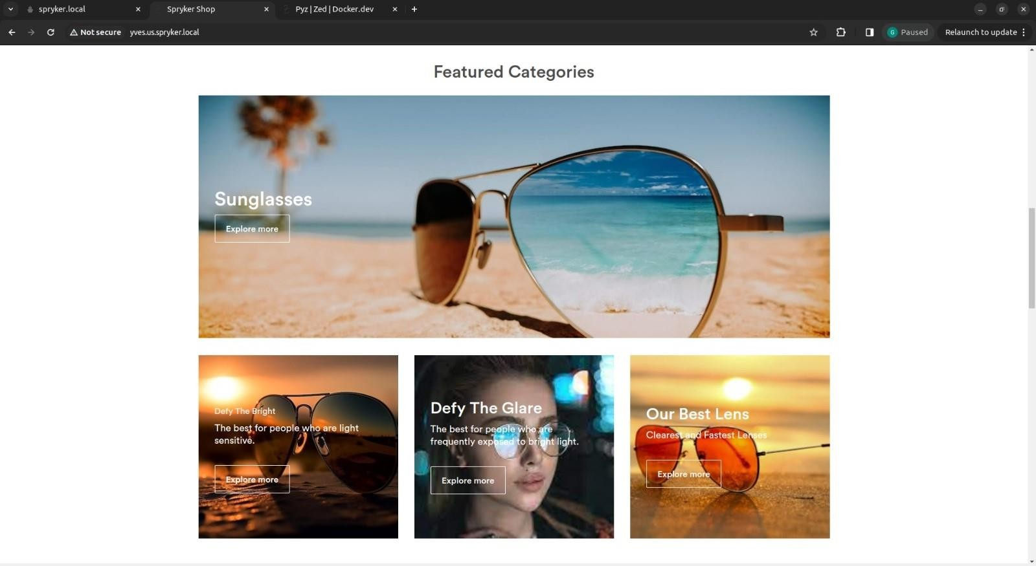

**Fig.22 Page Showing the Featured Products on the website**

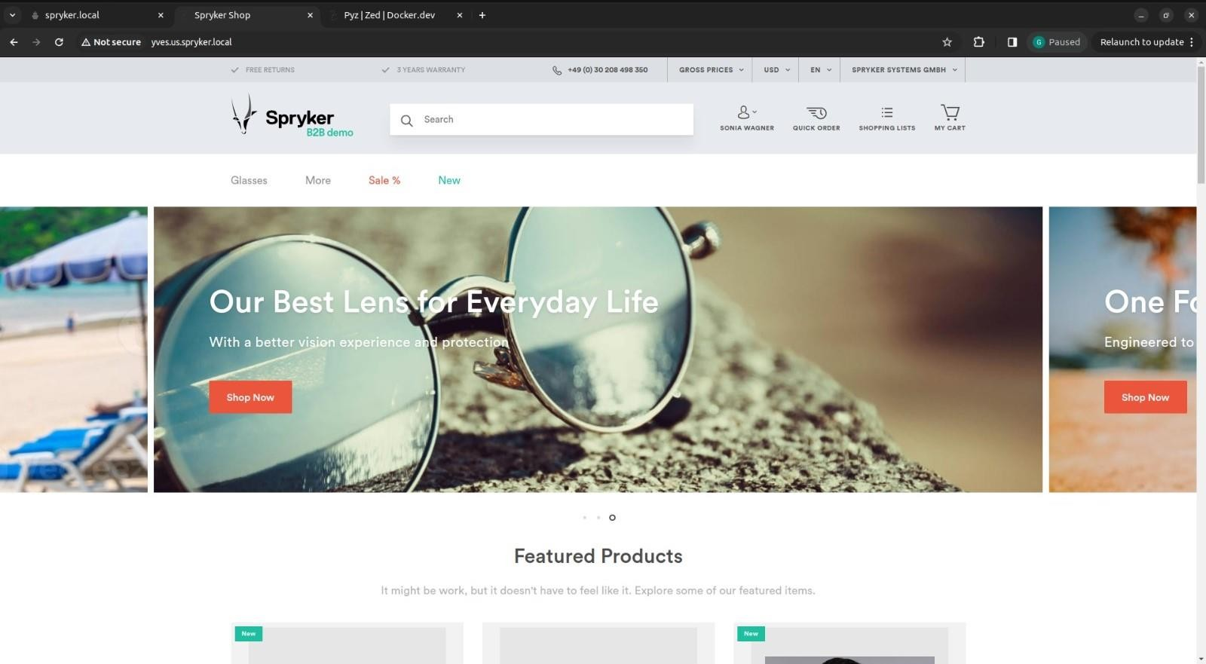

**Fig.23 FrontPage of the Ecommerce Website**

26

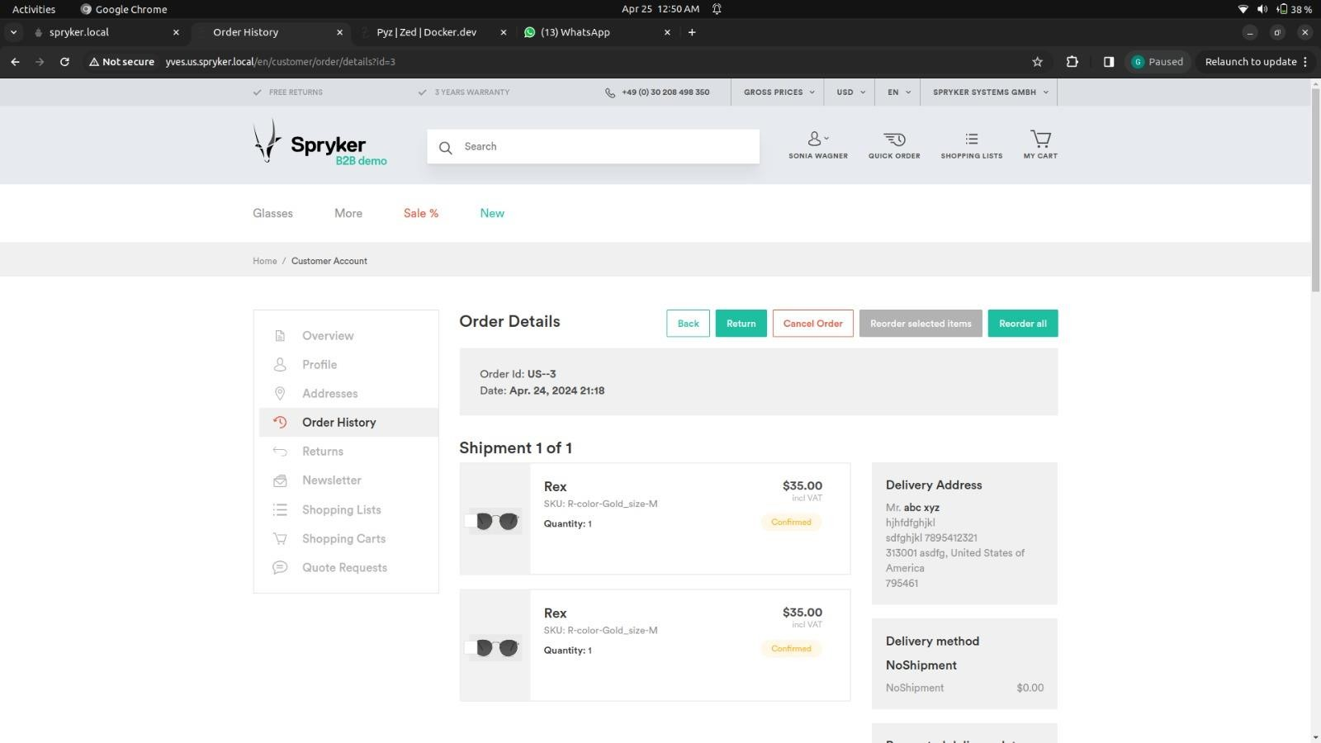

**Fig.24 Showing the confirmed order**

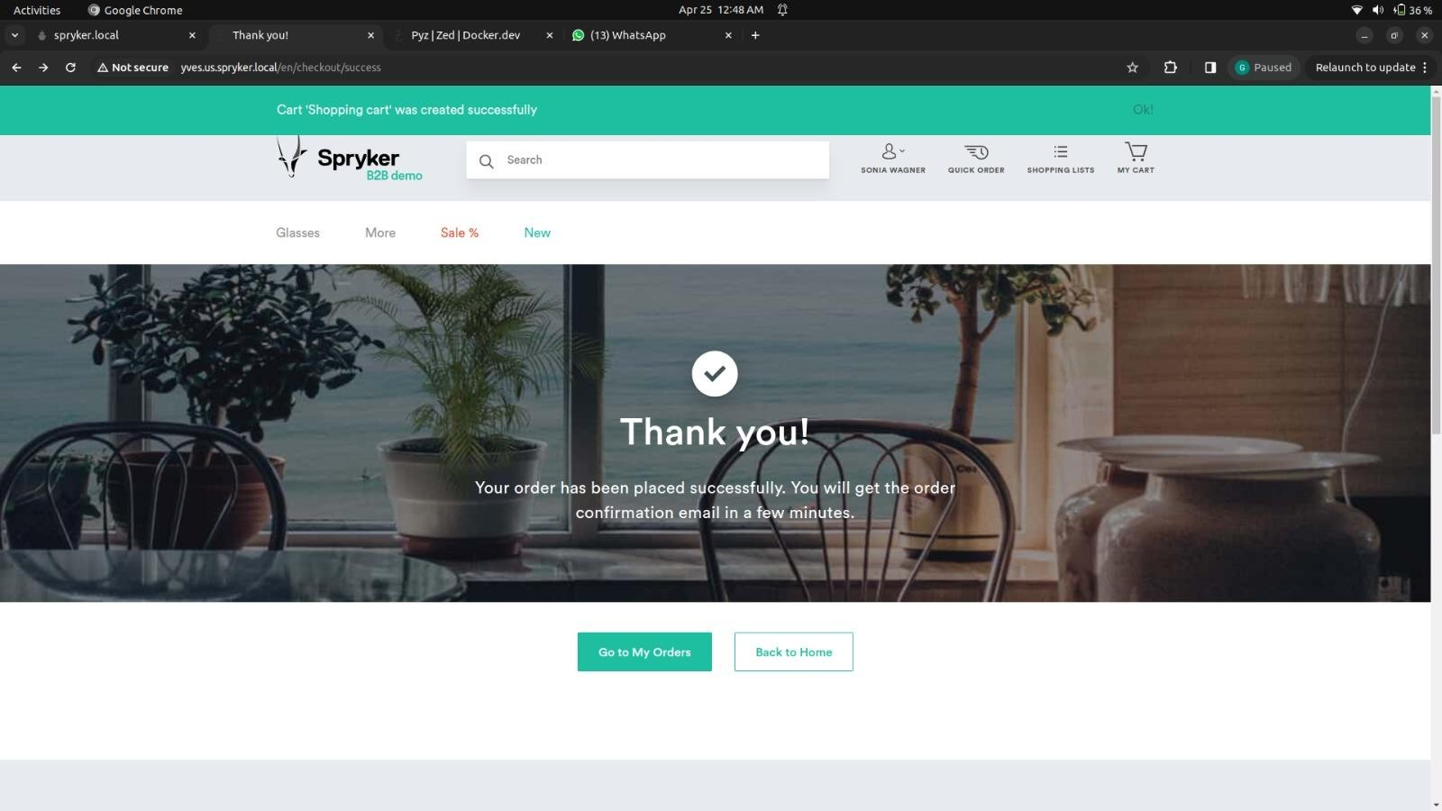

**Fig.25 Showing the confirmed order for the authenticated customer**

27

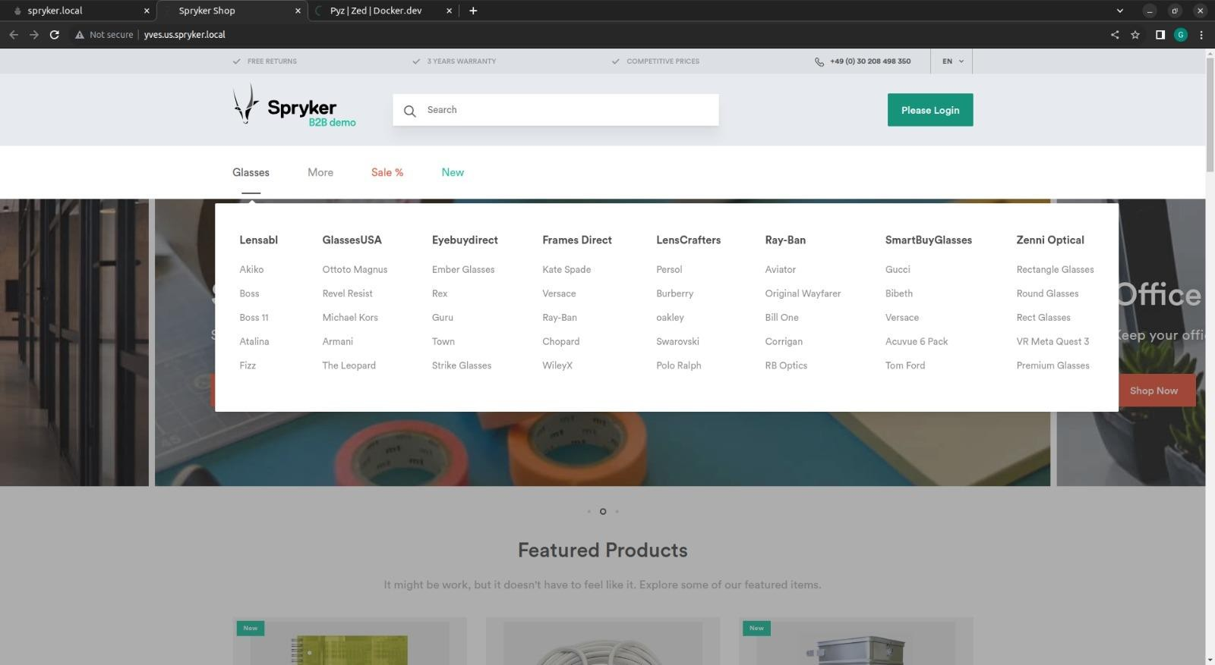

**Fig.26 Product Catalog**

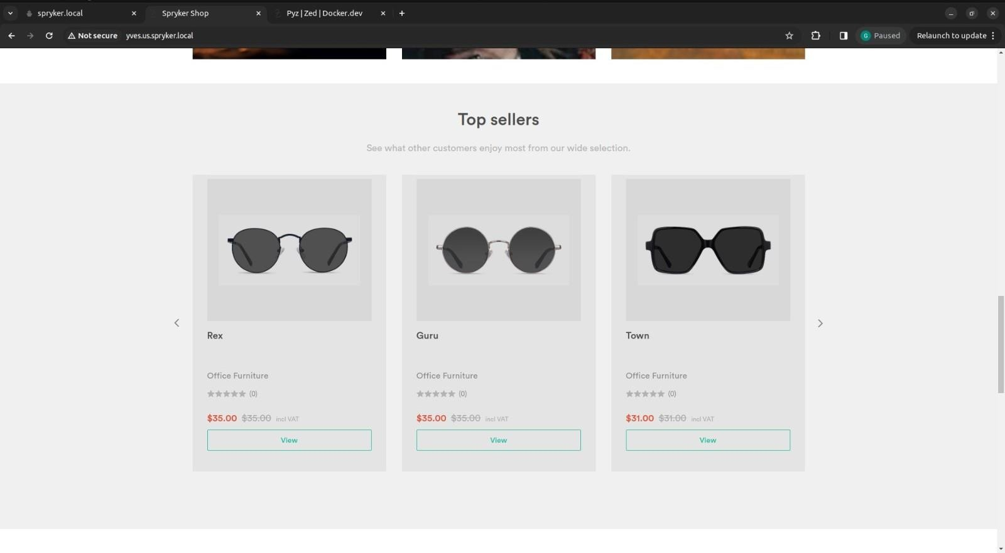

**Fig.27 Top Categories of Transitions Lens Store**

# BIBLIOGRAPHY:

28

1. Spryker documentation (<https://docs.spryker.com/index.html>)
2. Spryker Academy

( [https://safari.spryker.com](https://safari.spryker.com/))

29